**Version Controlling Activity # 4**

**20K-0409 Mukand**

**After creating project**

**Task 2: Import Git repo:**

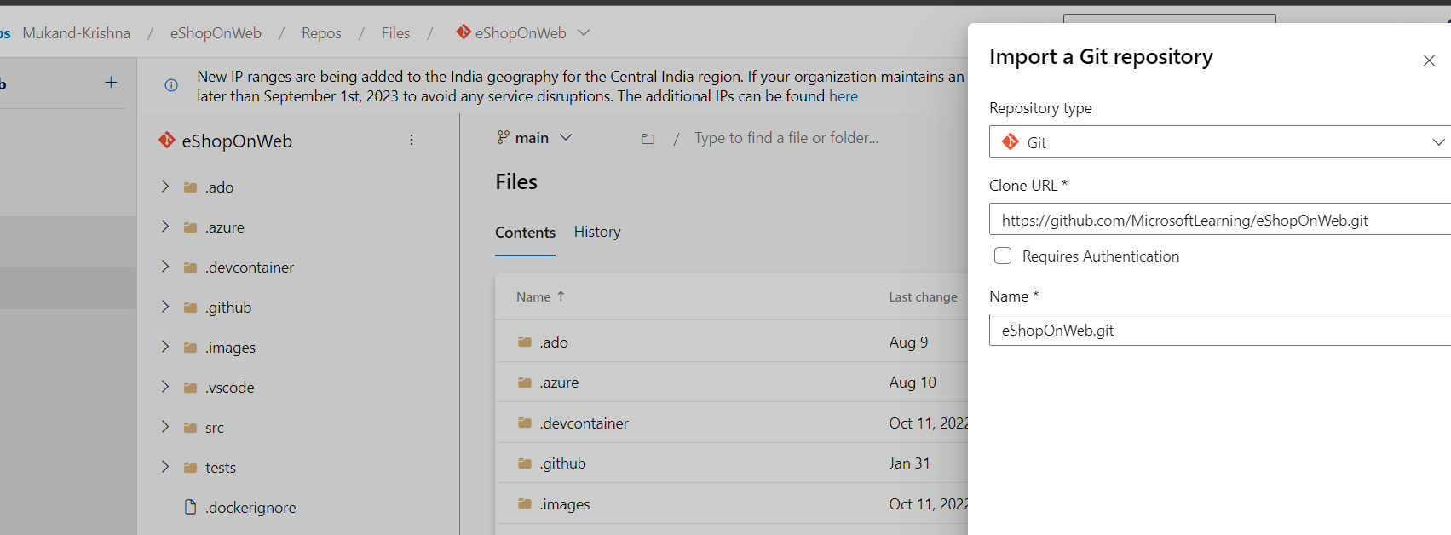

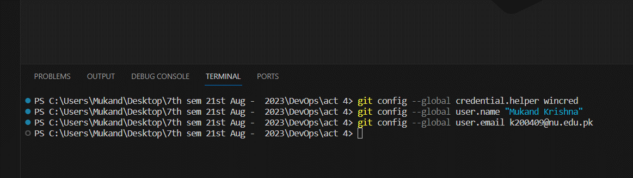

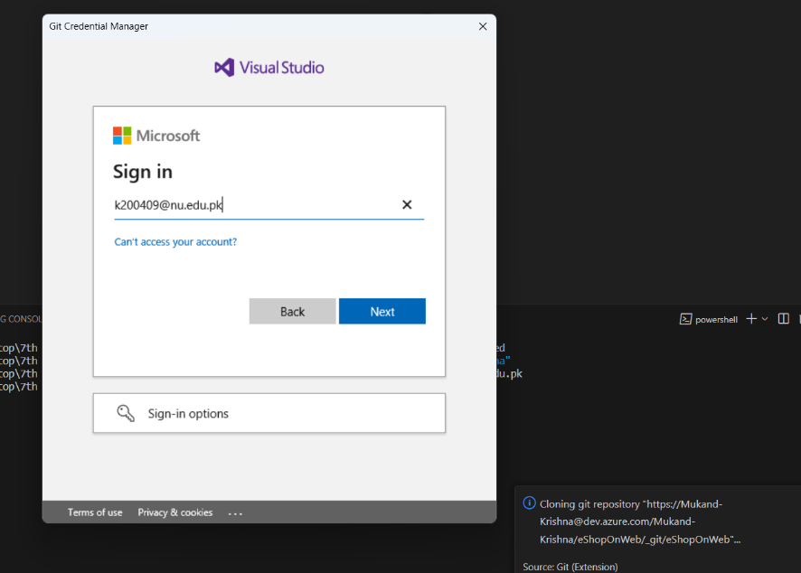

**Exercise 2: Save work with commits:**

**TASK 1:**

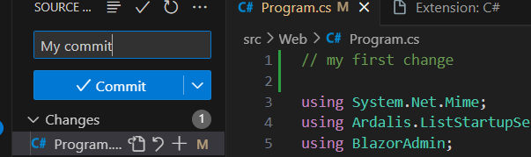

**TASK 2:**

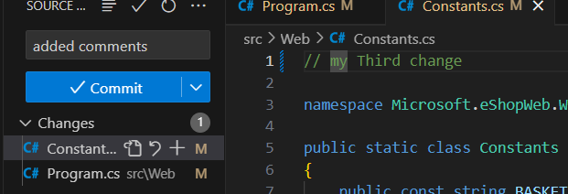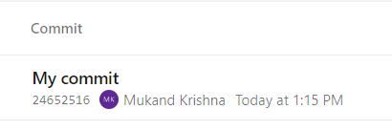

**Exercise 3: Review History:**

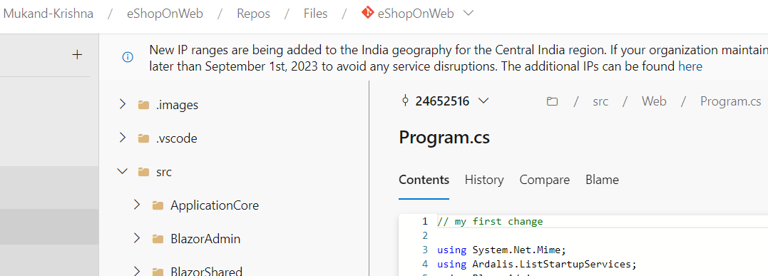

**Exercise 4: Work with branches**

**Task 1: Create a new branch in your local repository**

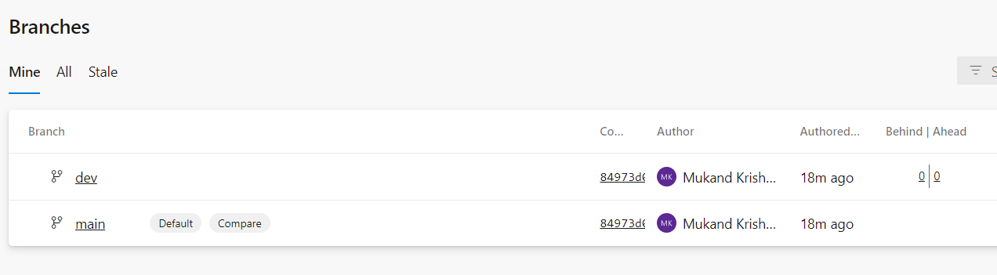

**TASK 2: delete**

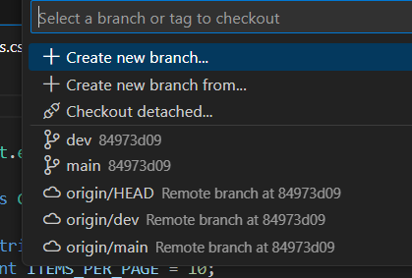

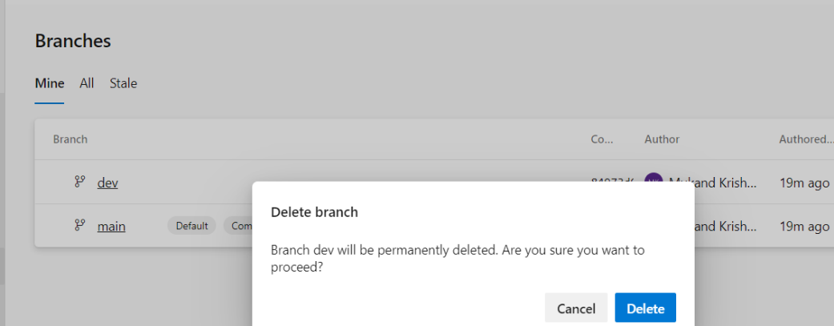

**origin/dev branch no longer appears:**

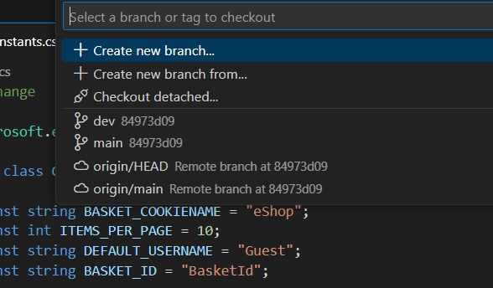

**Task 3: Restore a branch**

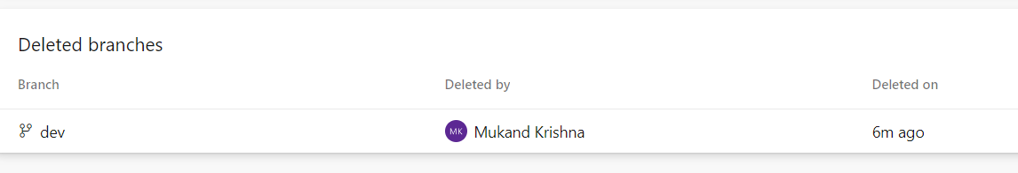

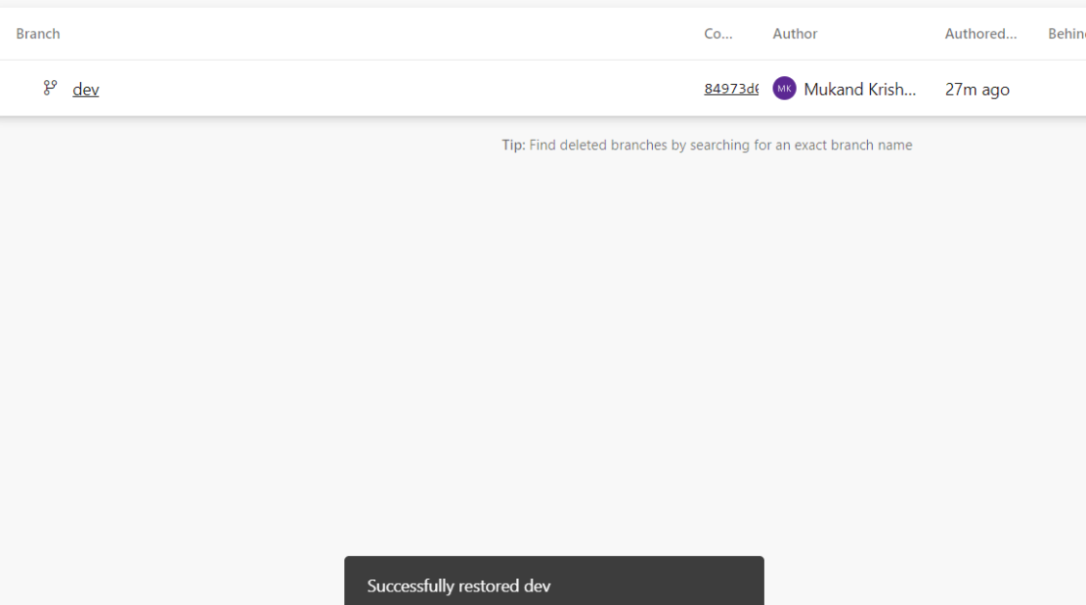

**Task 4: Branch Policies:**

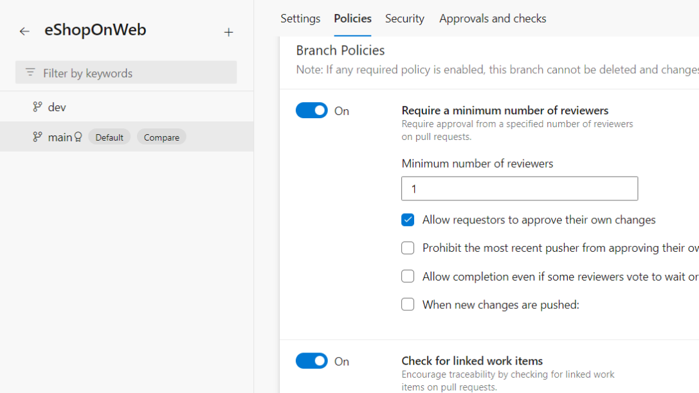

**Task 5: Testing branch policy:**

**Task 6: Working with Pull Requests:**

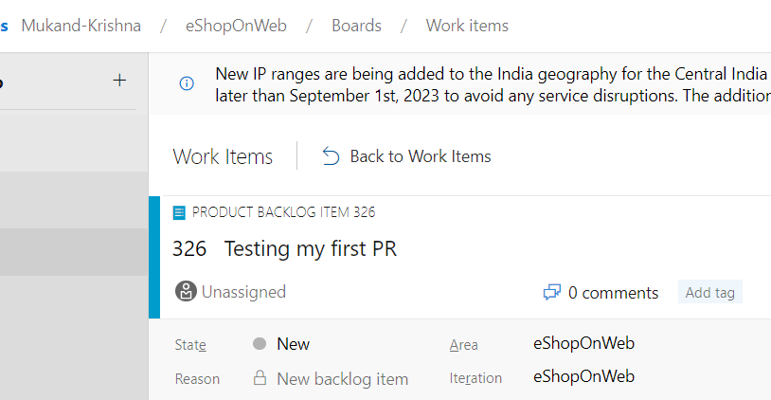

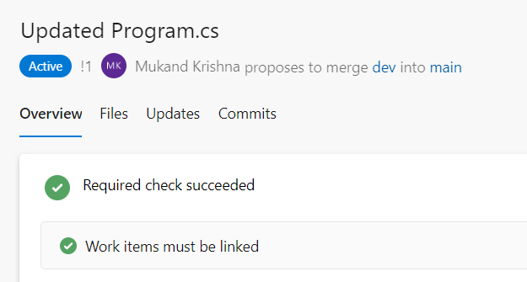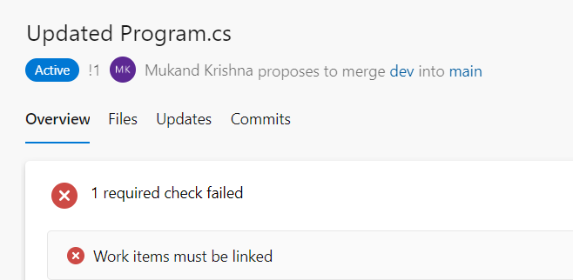

**File tab:**

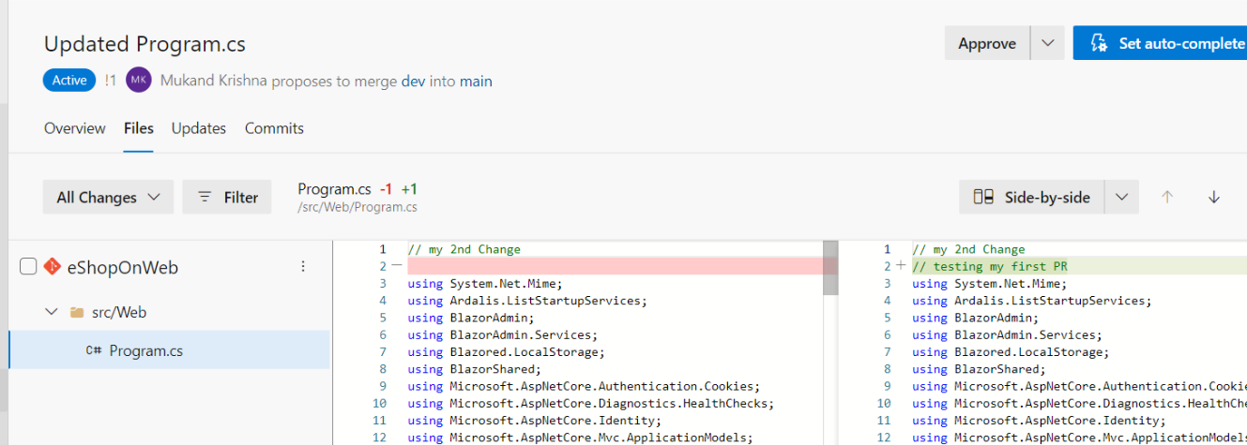

**Task 7: Applying tags**



